Seasons in Australia
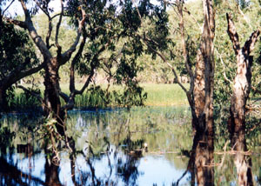

Ian Wilson
7.2 Science

Introduction

Australia is a very large continent with a variety of climatic areas, which causes two main seasonal patterns.

Tropics

The tropical areas of Australia have a wet and dry season only. this includes the areas
Australia has a wet season called the monsoon season, which lasts about six months (between November and March).

Due to the size of the continent, there is not one single seasonal calendar for the entire continent. Instead there are six climatic zones and this translates as two main seasonal patterns.

There are a number of different possibilities for the weather in these regions.

